INTRODUCTION
Computers have revolutionized the field of education. The rise of internet has made computers a real knowledge bank providing distant education, corporate access etc. But the task of computers in education can be comprehensive only when the evaluation system is also computerized. The real assessment of students lies in the proper evaluation of their papers. Conventional paper evaluation leaves the student at the mercy of the teachers. Lady luck plays a major role in this current system of evaluation. Also the students don’t get sufficient opportunities to express their knowledge. Instead they are made to regurgitate the stuff they had learnt in their respective text books. This hinders their creativity to a great extent. Also a great deal of money and time is wasted. The progress of distance education has also been hampered by the non-availability of a computerized evaluation system. This paper addresses how these striking deficiencies in the educational system can be removed.

CHAPTER 1
CONVENTIONAL EVALUATION SYSTEM

The evaluation system at present involves the students writing their answers for the questions asked, in sheets of paper. This is sent for correction to the corresponding staff. The evaluator may be internal or external depending on the significance of the exam. The evaluator uses the key to correct the paper and the marks are awarded to the students based on the key.
1.1. DEMERITS:
1. EVALUATORS BIASNESS:
This has been the major issue of concern for the students. When the staff is internal, there is always a chance for him to be biased towards few of his pupils. This is natural to happen and the evaluator cannot be blamed for that.
2. IMPROPER EVALUATION:
Every evaluator will try to evaluate the papers given to him as fast as possible. Depending on the evaluation system he’ll be given around ten minutes to correct a single paper. But rarely does one take so much time in practice. They correct the paper by just having an out look of the paper. This induces the students to write essays so that marks can be given for pages and not for contents. So students with real knowledge are not really rewarded.
3. APPEARANCE OF THE PAPER:
The manual method of evaluation is influenced very much by the appeal of the paper. If the student is gifted with a good handwriting then he has every chance of outscoring his colleagues.

4. TIME DELAY:
Usually manual correction takes days for completion and the students get their results only after months of writing exams. This introduces unnecessary delays in transition to the higher classes.
5. NO OPPURTUNITY TO PRESENT STUDENT IDEAS:
The students have really very little freedom in presenting their ideas in the conventional system. The student has to write things present in his text book.

CHAPTER 2
PROPOSED SYSTEM

2.1 BASIS:
Having listed out the demerits of the current evaluation system, the need for a new one becomes the need of the hour. This proposal is all about computerizing the evaluation system by applying the concept of Artificial Neural Networks.
2.2 SOFTWARE:
The software is built on top of the neural net layers below. This software features all the requirements of a regular answer sheet, like the special shortcuts for use in Chemistry like subjects where subscripts to equation are used frequently and anything else required by the student.

A SIMPLE NEURON:
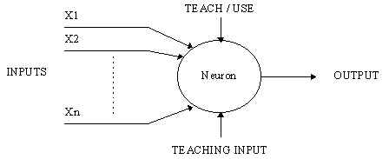
Figure 1. A Simple Neuron

An artificial neuron is a device with many inputs and one output.
The neuron has two modes of operation; the training mode and the using mode. In the training mode, the neuron can be trained to fire (or not), for particular input patterns. In the using mode, when a taught input pattern is detected at the input, its associated output becomes the current output. If the
Input pattern does not belong in the taught list of input patterns, the firing rule is used to determine whether to fire or not.

2.3 FIRING RULES:
The firing rule is an important concept in neural networks and accounts for their high flexibility. A firing rule determines how one calculates whether a neuron should fire for any input pattern. It relates to all the input patterns, not only the ones on which the node was trained.

CHAPTER 3
NEURAL NETWORK

An Artificial Neural Network (ANN) is an information processing paradigm that is inspired by the way biological nervous systems, such as the brain, process information. The key element of this paradigm is the novel structure of the information processing system. It is composed of a large number of highly interconnected processing elements (neurons) working in unison to solve specific problems.

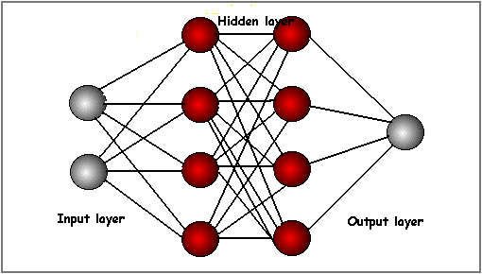

Figure 2: A Neural Network
The commonest type of artificial neural network consists of three groups, or layers, of units: a layer of "input" units is connected to a layer of "hidden" units, which is connected to a layer of "output" units. (See Figure 2)The activity of the input units represents the raw information that is fed into the network.

The activity of each hidden unit is determined by the activities of the input units and the weights on the connections between the input and the hidden units.
The behavior of the output units depends on the activity of the hidden units and the weights between the hidden and output units
Neural networks are typically organized in layers. Layers are made up of a number of interconnected 'nodes' which contain an 'activation function'. In computational networks, the activation function of a node defines the output of that node given an input or set of inputs. A standard computer chip circuit can be seen as a digital network of activation functions that can be "ON" (1) or "OFF" (0), depending on input. Patterns are presented to the network via the 'input layer', which communicates to one or more 'hidden layers' where the actual processing is done via a system of weighted 'connections'. The hidden layers then link to an 'output layer' where the answer is output as shown in the graphic.
ANNs, like people, learn by example. An ANN is configured for a specific application, such as pattern recognition or data classification, through a learning process. There are two types of learning process: Supervised learning process and the unsupervised learning process.
Supervised learning is a machine learning technique for deducing a function from training data. The training data consist of pairs of input objects (typically vectors), and desired outputs. The output of the function can be a continuous value (called regression), or can predict a class label of the input object (called classification). The task of the supervised learner is to predict the value of the function for any valid input object after having seen a number of training examples (i.e. pairs of input and target output). To achieve this, the learner has to generalize from the presented data to unseen situations in a
"reasonable" way. The parallel task in human and animal psychology is often referred to as concept learning.

Unsupervised learning is a class of problems in which one seeks to determine how the data are organized. It is distinguished from supervised learning, in that the learner is given only unlabeled examples. Unsupervised learning is closely related to the problem of density estimation in statistics. However unsupervised learning also encompasses many other techniques that seek to summarize and explain key features of the data. One form of unsupervised learning is clustering. Among neural network models, the Self-Organizing Map (SOM) and Adaptive resonance theory (ART) are commonly used unsupervised learning algorithms.

CHAPTER 4
BASIC STRUCTURE OF EXAMINATION SYSTEM

The examination system can be divided basically into three groups for each of the following class groups:
a. Primary education
b. Secondary education
c. Higher secondary education
The examination system has to be entirely different for each of the above groups because of their different learning objectives. In this paper the primary education is not dealt because of its simplicity.

4.1. SOME BASIC DISTINCTIONS BETWEEN THE LATER TWO GROUPS :

a. In secondary education importance should be given to learning process. That is the question paper can be set in such a fashion so that the students are allowed to learn instead of giving importance to marks. This will help in putting a strong base for them in future. Also a grading system can be maintained for this group.
b. In higher secondary importance shall be given to specialization. That is the students will be allowed to choose the topic he is more interested. This is accomplished by something called adaptive testing viz. the computer asks more questions in a topic in which the student is confident of answering or has answered correctly.

4.2. ORGANIZATION OF THE REFERENCE SITES:

The reference sites must be specifically organized for a particular institution or a group of institutions. This can also be internationally standardized. The material in the website must be organized in such a way that each point or group of points in it is given a specific weight age with respect to a particular subject. This would result in intelligent evaluation by the system by giving more marks to the more relevant points.

4.3. REQUIREMENT OF THE NEW GRAMMAR:

The answer provided by the student is necessarily restricted to a new grammar. This grammar is a little different from the English grammar.
E.g.:-If one is to negate a sentence it is compulsory to write the ‘not’ before verb.

4.4. QUESTION PATTERN AND ANSWERING:

The question pattern depends much on the subject yet the general format is dealt in here.
For instance in computer science if a question is put up in operating systems then the student starts answering it point by point. The system searches for the respective points in the given reference websites and gives appropriate marks for them. The marks can be either given then and there for each of his point or given at last. Both the above said methods have their own advantages and disadvantages.

CHAPTER 5
ROLE OF NEURAL NETWORK
Tasks cut out for the neural network:
a. Analyze the sentence written by the student.
b. Extract the major components of each sentence.
c. Search the reference for the concerned information.
d. Compare the points and allot marks according to the weight age of that point.
e. Maintain a file regarding the positives and negatives of the student.
f. Ask further questions to the student in a topic he is clearer off.
g. If it feels of ambiguity in sentences then set that answer apart and continue with other answers and ability to deal that separately with the aid of a staff.

CHAPTER 6
ANALYSIS OF LANGUAGE BY NEURAL NETWORK

6.1. PERCEPTRON
Perceptron learning was used for learning past tenses of English verbs in Rumelhart and McClelland, 1986a. This was the first paper that claimed to have demonstrated that a single mechanism can be used to derive past tense forms of verbs from their roots for both regular and irregular verbs.

6.2. PREDICTION OF WORDS (ELMAN 1991):
Elman’s paper demonstrated how to predict the next word in a sentence using the back propagation algorithm. Back propagation, or propagation of error, is a common method of teaching artificial neural networks how to perform a given task. It was first described by Paul Werbos in 1974, but it wasn't until 1986, through the work of David E. Rumelhart, Geoffrey E. Hinton and Ronald J. Williams, which it gained recognition, and it led to a “renaissance” in the field of artificial neural network research. It is a supervised learning method. It requires a teacher that knows, or can calculate, the desired output for any given input. It is most useful for feed-forward networks (networks that have no feedback, or simply, that have no connections that loop). The term is an abbreviation for "backwards propagation of errors". Back propagation requires that the activation function used by the artificial neurons (or "nodes") is differentiable.

Summary of the back propagation technique:
1. Present a training sample to the neural network.
2. Compare the network's output to the desired output from that sample. Calculate the error in each output neuron.
3. for each neuron, calculate what the output should have been, and a scaling factor, how much lower or higher the output must be adjusted to match the desired output. This is the local error.
4. Adjust the weights of each neuron to lower the local error.
5. Assign "blame" for the local error to neurons at the previous level, giving greater responsibility to neurons connected by stronger weights.
6. Repeat from step 3 on the neurons at the previous level, using each one's "blame" as its error.
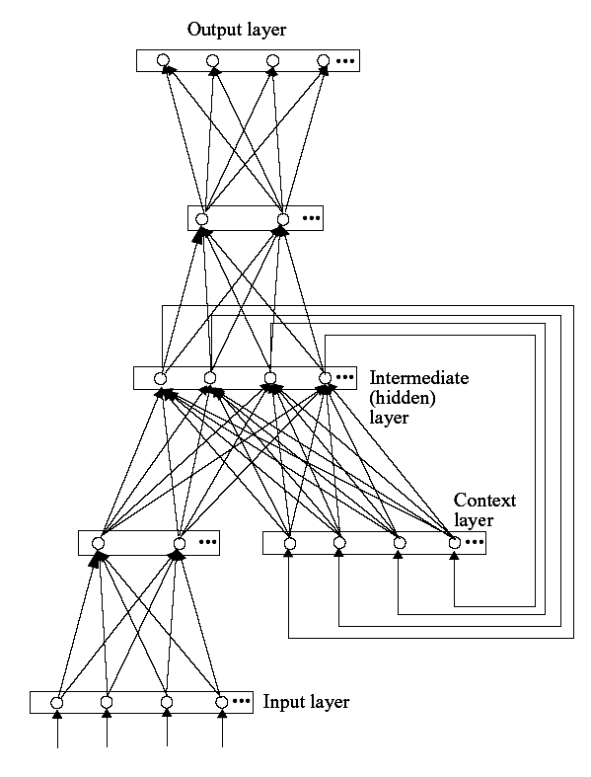

Figure 3: Network Architecture for Word Prediction (Elman 1991)

The input layer receives words in sentences sequentially, one word at a time. Words are represented by assigning different nodes in the input layer for different words. The task for the network is to predict the next input word. Given an input word and the context layer activity, the network has to activate a set of nodes in the output layer (which has the same representation as in the input) that possibly is the next word in the sentence. The average error was found to be 0.177.

6.3. NON-SUPERVISED LEARNING ALGORITHM:
They were invented by a man named Teuvo Kohonen, a professor of the Academy of Finland, and they provide a way of representing multidimensional data in much lower dimensions. This process of reducing the dimensionality of vectors is essentially a data compression technique known as vector quantization. In addition, the kohonen technique creates a network that stores information in such a way that any topological relationships with the training set are maintained.
Self-Organizing Feature maps are competitive neural networks in which neurons are organized in a two-dimensional grid (in the simplest case) representing the feature space? According to the learning rule, vectors that are similar to each other in the multidimensional space will be similar in the two-dimensional space. SOFMs are often used just to visualize an n-dimensional space, but its main application is data classification.
Suppose we have a set of n-dimensional vectors describing some objects (for example, cars). Each vector element is a parameter of an object (in the case with cars, for instance – width, height, weight, the type of the engine, power, gasoline tank volume, and so on). Each of such parameters is different for different objects. If you need to determine the type of a car by looking only on such vectors, then using SOFMs, you can do it easily.

Self-organizing feature map (SOFM, Kohonen, 1982) is an unsupervised learning algorithm that forms a topographic map of input data. After learning, each node becomes a prototype of input data, and similar prototypes tend to be close to each other in the topological arrangement of the output layer. SOFM has ability to form a map of input items that differ from each other in a multi-faceted ways. It would be intriguing to see what kind of map is formed for lexical items, which differs from each other in various lexical-semantic and syntactic dimensions. Ritter and Kohonen presented a result of such trial, although in a very small scale (Ritter and Kohonen, 1990). The hardest part of the model design was to determine the input representation for each word. Their solution was to represent each word by the context in which it appeared in the sentences. The input representation consisted of two parts: one that serves as an identifier of individual word and another that represented context in which the words appear.

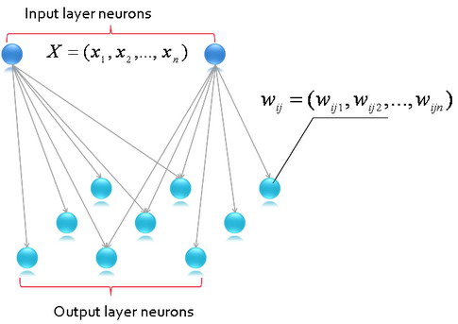

Figure 4: Architecture of SOFM

The SOFM NN consists of two layers of neurons (Fig. 4). The first layer is not actually a neurons layer; it only receives the input data and transfers it to the second layer. Let us consider the simplest case, when neurons of the second layer are combined into a two-dimensional grid. Other structures, like three-dimensional spheres, cylinders, etc., are out of the scope of this article. Each neuron of the third layer connects with each neuron of the second layer. The number of neurons in the second layer can be chosen arbitrarily, and differs from task to task. Each neuron of the second layer has its own weights vector whose dimension is equal to the dimension of the input layer. The neurons are connected to adjacent neurons by a neighborhood relation, which dictates the topology or structure of the map. Such a neighborhood relation is assigned by a special function called a topological neighborhood.

6.4. ADAPTIVE RESONANCE THEORY

The basic idea of Adaptive Resonance Theory (ART) (Gross berg, 1980) is that to achieve a stable learning, top-down expectation connections are directed to only one direction, from the input layer towards the output layer. In ART, in addition to the connection from the input layer to the output layer, there is a connection from the output layer to the input layer that is used to project expectations onto the input layer. The particular architecture described here is called ART1, which learns arrays of binary data (values of each variable either 1 or 0) (Carpenter and Gross berg, 1987). Original ART algorithm is defined in terms of differential equation and thus the network.

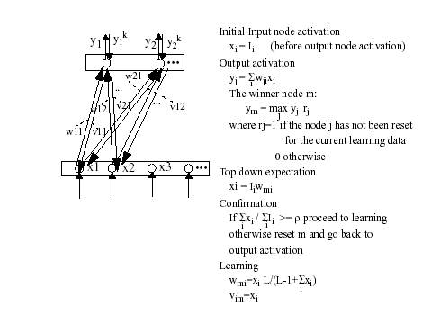

In 1976, Gross berg (Gross berg, 1976) introduced a model for explaining biological phenomena. The model has three crucial properties: a normalization of the total network activity. Biological systems are usually very adaptive to large changes in their environment. For example, the human eye can adapt itself to large variations in light intensities;
- Contrast enhancement of input patterns. The awareness of subtle deference’s in input patterns can mean a lot in terms of survival. Distinguishing a hiding panther from a resting one makes all the difference in the world. The mechanism used here is contrast enhancement;
- Short-term memory (STM) storage of the contrast-enhanced pattern. Before the input pattern can be decoded, it must be stored in the short-term memory. The long-term memory (LTM) implements an arousal mechanism (i.e., the classication), whereas the STM is used to cause gradual changes in the LTM.

The system consists of two layers, F1 and F2, which are connected to each other via the LTM
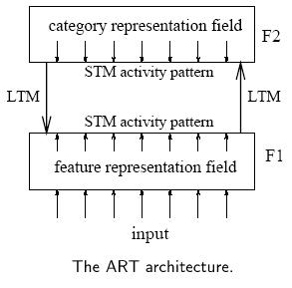

The input pattern is received at F1, whereas classication takes place in F2. As mentioned before, the input is not directly classified. First a characterization takes place by means of extracting features, giving rise to activation in the feature representation field. The expectations, residing in the LTM connections, translate the input pattern to a categorization in the category representation field. The classification is compared to the expectation of the network, which resides in the LTM weights from F2 to F1. If there is a match, the expectations are strengthened, otherwise the classification is rejected.

ART1: The simplified neural network model
The ART1 simplified model consists of two layers of binary neurons (with values 1 and 0), called F1 (the comparison layer) and F2 (the recognition layer)
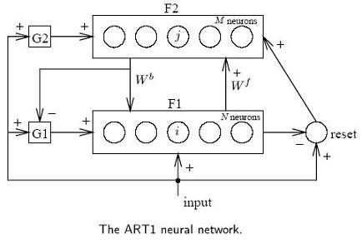
Each neuron in F1 is connected to all neurons in F2 via the continuous-valued forward long term memory (LTM) Wf, and vice versa via the binary-valued backward LTM Wb. The other modules are gain 1 and 2 (G1 and G2), and a reset module. Each neuron in the comparison layer receives three inputs: a component of the input pattern, a component of the feedback pattern, and a gain G1. A neuron outputs a 1 if and only if at least three of these inputs are high: the 'two-thirds rule.' The neurons in the recognition layer each compute the inner product of their incoming (continuous-valued) weights and the pattern sent over these connections. The winning neuron then inhibits all the other neurons via lateral inhibition. Gain 2 is the logical 'or' of all the elements in the input pattern x. Gain 1 equals gain 2, except when the feedback pattern from F2 contains any 1; then it is forced to zero. Finally, the reset signal is sent to the active neuron in F2 if the input vector x and the output of F1 di
er by more than some vigilance level.

Operation
The network starts by clamping the input at F1. Because the output of F2 is zero, G1 and G2 are both on and the output of F1 matches its input. The pattern is sent to F2, and in F2 one neuron becomes active. This signal is then sent back over the backward LTM, which reproduces a binary pattern at F1.

Gain 1 is inhibited, and only the neurons in F1 which receive a 'one' from both x and F2 remain active. If there is a substantial mismatch between the two patterns, the reset signal will inhibit the neuron in F2 and the process is repeated.
- Initialization:
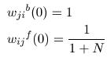Where N is the number of neurons in F1, M the number of neurons in F2, 0 µ i < N,
and 0 ≤ j <M. Also, choose the vigilance threshold ρ, 0 ≤ ρ ≤ 1;
- Apply the new input pattern x:
- compute the activation values y0 of the neurons in F2: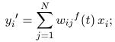
- select the winning neuron k (0 ≤ k <M):
- vigilance test: if
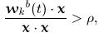Where. Denotes inner product, go to step 7, else go to step 6. Note that essentially is the inner product,which will be large if and near to each other;
- Neuron k is disabled from further activity. Go to step 3;
- Set for all l, 0 ≤ l < N:
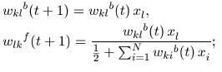
- Re-enable all neurons in F2 and go to step 2.
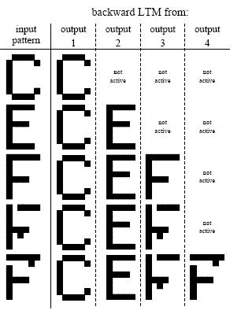
An example of the behavior of the Carpenter Gross berg network for letter patterns. The binary input patterns on the left were applied sequentially. On the right the stored patterns are shown.

CHAPTER 7

TRAINING

The training of the neural network is the vital part of success of this proposal. The training involves a team of experienced
a. Subject Masters
b. Language Masters
c. Psychology cum Evaluation Masters
The subject masters train the net to have a general idea of paper evaluation. The language masters give specific training to the net to expect for various kinds of sentences. The psychology masters train the net for various levels of error acceptance in semantics. They also train the net about the common mistakes the student is expected to make in sentences. The neural network is put into a phase of supervised training for a specific time until its error margin is less than what is allowed. This beta version can be checked for common defects and improvised further according to the requirements of the students.

CHAPTER 8

MERITS
8.1. EFFECTIVE DISTANT EDUCATION PROGRAMMES:
The distant education programmed at present has no effective examination system. If such a model is implemented, the distant education methodology will lead to a greater success.
8.2. COMPETITIVE EXAMS TO BECOME MORE REALISTIC:
The competitive exams at present are restricted only to objective questions. This is attributed to the human factor. This situation can be changed and even descriptive questions can be asked in such examinations after the implementation of this system.
8.3. EVALUATOR’S BIASNESS, HANDWRITING-NOT REALLY AN ISSUE:
Majority of the students have trouble in negotiating the above factors in any examination. This system is really a relief to all such grievances.
8.4. FREEDOM OF IDEAS:
The student has the liberty to write any point provided they are valid and relevant. This really was a hurdle to students as they are made to write things known to their staff or given in their text book.
8.5. SPECIALISATION:
The student can start his specialization early with just basics of everything. The student is just expected to know the basics by the computer say in the first round of questions. In the successive rounds of questionnaire the computer asks questions related to the topic he is much better versed in. This can seldom be expected in our conventional system. Thus it leads to early specialization with the student deciding on the topics he is to learn.

CHAPTER 9

DEMERITS

1 The student has to learn few basic changes in grammar.
2 The computer cannot be cent percent error free. There is of course some error margin but it is very little when compared to a human.
3 Reasoning type questions cannot be evaluated by the computer.
4. Subjects like Mathematics, English cannot be evaluated using this model.

CHAPTER 10

CONCLUSION

The proposal explained above can be easily integrated into a working model. This change of evaluation system results does a lot of good for students, as well is expected to change the educational system. A research on this proposal would further make the system much more efficient.

CHAPTER 11

REFERENCES

[1] A Minimum Description Length Approach to Grammar Inference- Peter Grunwald
[2] A Neural Network approach to topic spotting – Erik Weiner
[3] Everything that Linguists have always wanted to know about Conventionalism
[4] Two Stages in Parsing: Early automatic and Late Controlled Process – Anja Hakne & Angela D. Friederici
[5] Concerning a General Framework for the Development of Intelligent System – Dan Ventura & Tony R. Martinez
[6] Comparative Experiments Disambiguating Word Senses: An illustration of the Role of Bias in Machine Learning – Raymond J. Mooney
[7] A Re-examination of Text Categorization methods – Yimin Yang & Xim Liu

